AdMyBrand Insights 🚀

AdMyBrand Insights is an analytics dashboard designed to visualize and manage brand-related data through a customizable, Galaxy-themed interface. Built with modern web technologies, it offers a seamless and interactive user experience tailored for both aesthetics and functionality.

🌐 Live Demo

<https://dashboard-ash-1.vercel.app/>

**🛠 Tech Stack**

- React

- Tailwind CSS

- Vite

- Framer Motion(for animations and transitions)

- Skiper (for smooth UI transitions)

📦 Installation

To run the project locally:

git clone

npm install

npm run dev

**Features**

* ✅ **Responsive dashboard layout** for all screen sizes
* 🌗 **Light and dark mode toggle** with smooth gradient transitions
* 🧩 **Customizable layout settings** — toggle/hide dashboard elements as needed
* 🌌 **Galaxy-themed UI** with glow effects and animated visuals
* 📊 **Interactive charts** showing:
  + Website traffic breakdown (direct, referral, organic)
  + Viewer classification (new vs returning vs unique visitors)
  + Engagement & conversation analytics (Facebook, Instagram, etc.)
  + Revenue and monthly growth trends
* 🎯 **Smooth animations** powered by Framer Motion and Skiper
* **Export report features** for analytics

**Future Improvements**

* 🔄 Replace mock data with real-time API/database integration
* 🤖 Implement machine learning models to generate AI-driven insights
* 📈 Add advanced filtering and export features for analytics

**📸 Screenshots DARK MODE**

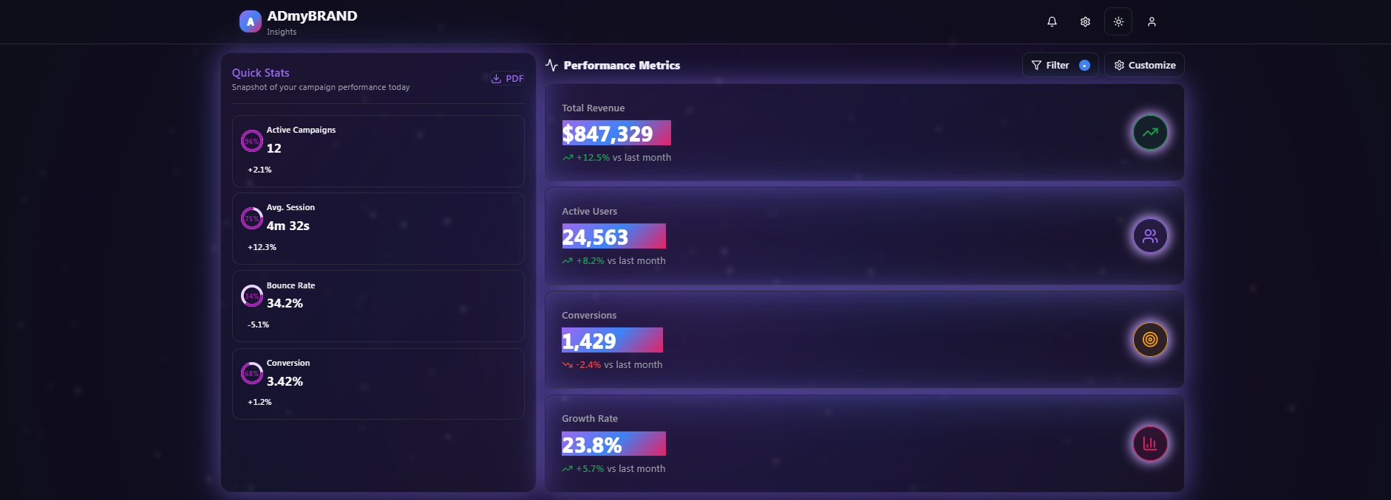

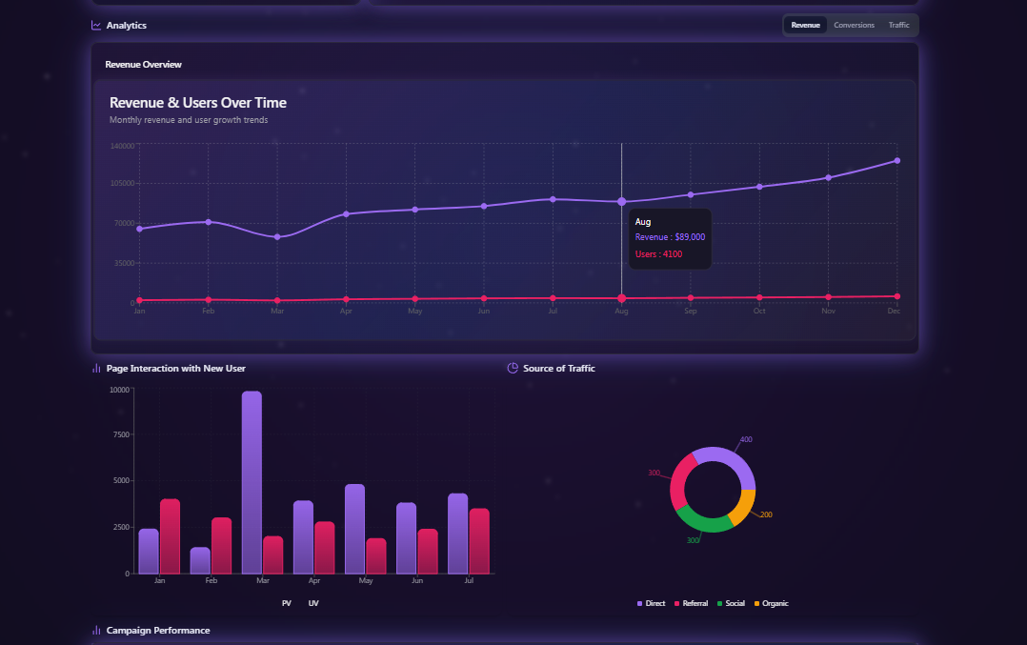

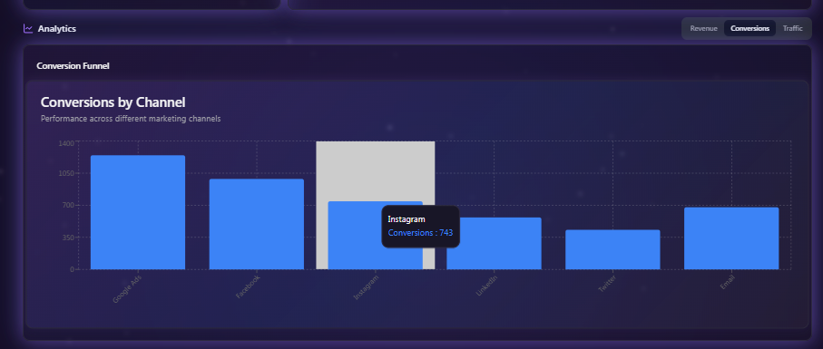

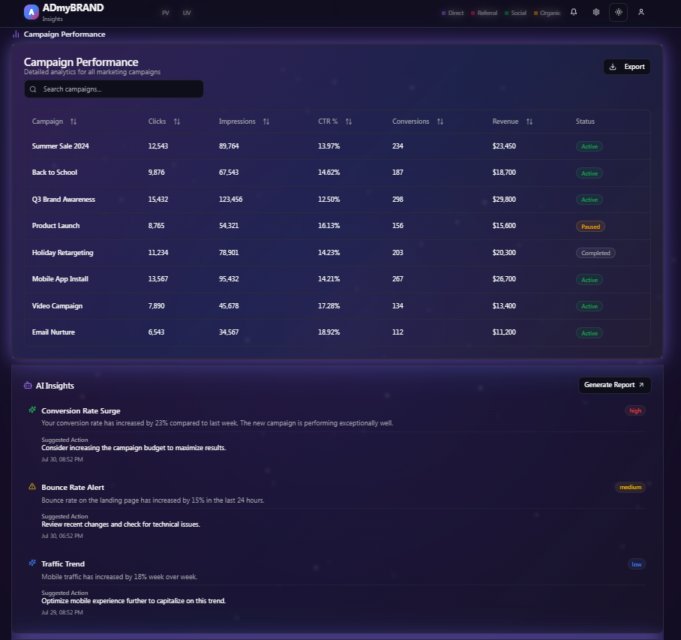

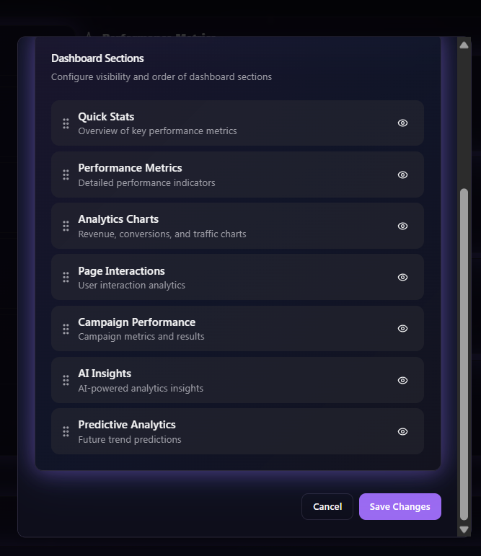

**📸 Screenshots LIGHT MODE**

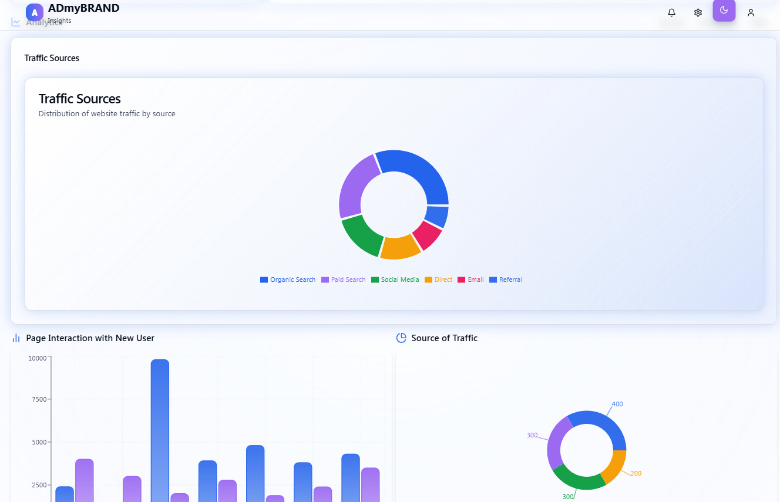

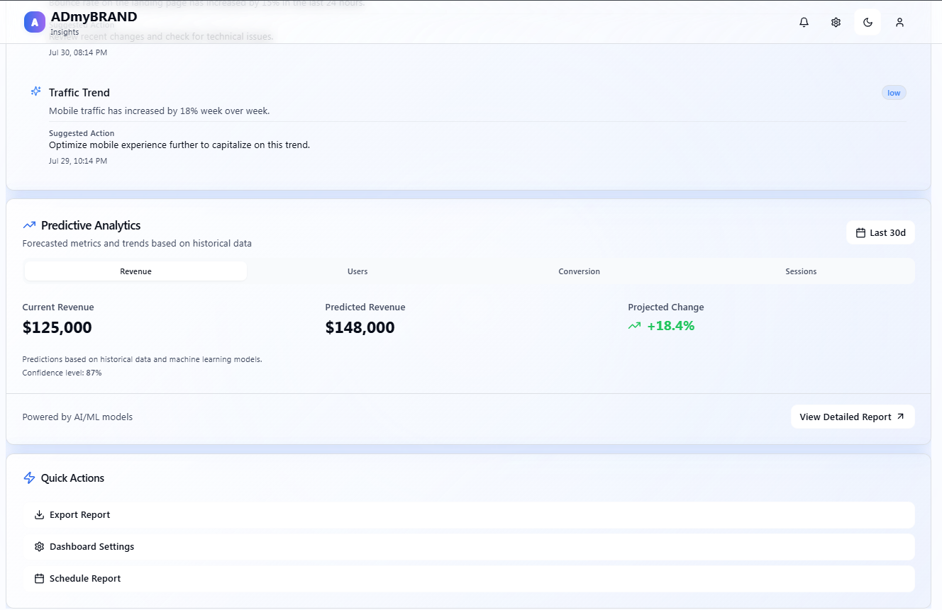

**## AI Tools Used**

- \*\***Lovable**\*\*: Used to generate a visually appealing **Galaxy-themed UI design**, assisting with layout ideas and color palettes.

- \*\***Dribbble**\*\*: Primary inspiration source for dashboard structure, UI animations, and design polish.

- \*\***GitHub Copilot**\*\*: Helped generate base component structures, layout scaffolding, and repetitive patterns.

- \*\***Cursor IDE used 60%**\*\*: Provided real-time AI support during development for layout iterations and quick fixes.

- \*\***ChatGPT**\*\*: Assisted with planning application logic, implementing advanced UI features, debugging layout behavior, and enhancing interactivity.

**## Prompts I use Example**

1. “Generate a Galaxy-themed React dashboard layout Design”

2. “Create a customizable layout settings panel with toggles for sidebar, header, and background options.”

3. “Fix inconsistent sidebar toggle behavior on screen resize .”

4. “Persist layout preferences in local storage using useEffect in React.”

5. “Use gradient background and smooth fade-out effect when toggling between light and dark mode in Tailwind.”

6. “Build a responsive layout with header, collapsible sidebar, and content section using Tailwind CSS.”

**## AI vs Manual Work Split**

- **AI-generated (approx. 40%)**

- Dashboard layout scaffolding and reusable components.

- Styling suggestions, including color gradients, shadows, and responsive behavior.

- Code snippets for light/dark mode switching, transitions, and animation helpers.

- **Manual coding (approx. 60%)**

- All application **logic and state management** manually written, especially layout customization settings.

**Logic was builtindependently with help of chatgpt** — especially for layout customization, settings persistence, and user interaction.

- With the help of **Cursor IDE and ChatGPT**, these manually built logics were **enhanced, optimized, and structured**.

- Fonts, hover states, and animations were ideated from internet, implemented through prompts in **ChatGPT/Copilot**, and visually refined using **Cursor IDE**.